INJURED SOUL

Herds of shuffling hollow corpses, roam the countryside, created by a crack between the Dead side and the void, corpses of the dead that are passing through the hollowing process. Injured souls bear the grisly marks that ended their lives, and make do with split bellies with entrails hanging free, broken limbs, and worse. They spread their depression through their presence.

Fashioned out of body parts harvested from dead creatures and restored to life by strange magic or weird science, a Injured Soul exists in a state of perpetual torment. Its mind is assailed by memories from a life it can only dimly remember, its sanity pushed to the breaking point by the horror of its existence. They grudgingly serve their makers, but if pushed too far, they might rebel, lashing out to destroy everything around them.

Because they are not totally merged into material world, they are rendered only in the air on an specie of electrical form, touch them with metal can be deadly.

They understand the Common Tongue but do not speak.

INJURED SOUL:

DIFFICULTY 5

Size 1/2 or 1 frightening undead

**Perception** 10 (+0); shadowsight

**Defense** 9; Health 20

**Strength** 11 (+1), Agility 9 (–1), Intellect 6 (–4), Will 12 (+2)

**Speed** 8; Shuffling Advance

Immune damage from metals, disease and poison; gaining Insanity;

asleep, charmed, dazed, diseased, fatigued, frightened,

poisoned, stunned

Headshot When the total of an attack with a weapon

against a Injured Soul is Critical or higher, the Inj. Soul takes damage

equal to its Health instead of the weapon’s normal damage.

Sluggish a Injured Soul can take only slow turns and cannot use

triggered actions.

**ATTACK OPTIONS**

**Soul touch** (melee) +1 with 1 boon (1d6 + 1 plus Injured Soul Plague);

the zombie makes the attack roll with 1 boon against a

grabbed creature.

**Injured Soul Plague** If the target is human or a human-like creature,

it must make a Strength challenge roll. On a failure, the target

becomes diseased. While it is diseased this way, the target

cannot heal damage and makes attack rolls and challenge

rolls with 1 bane. If it becomes incapacitated while diseased

this way, it dies instantly and rises up as a Convulsion Chaos

1d6 rounds later. Each time a creature diseased this way

completes a rest, it must make a Strength challenge roll. On a

failure, the creature takes a 1d6 penalty to Health. The penalty

lasts until this diseased affliction is removed. If this penalty

reduces the creature’s Health to 0 while it is diseased this

way, it dies and rises as a Convulsion Chaos 1d6 rounds later. After three

successes, the creature removes this diseased affliction.

**SPECIAL ATTACKS**

**Grasping Hands** The Injured soul makes a Strength attack roll

with 1 boon against the Agility of one target creature

within its reach. On a success, the target takes 1d3

damage and becomes **grabbed**.

**END OF THE ROUND**

Shuffling Advance The injured soul moves 1d3 yards toward

the nearest living creature.

Images reference:

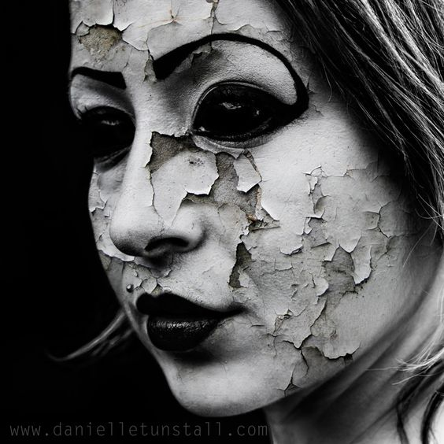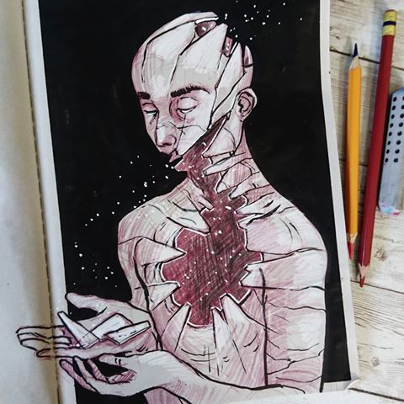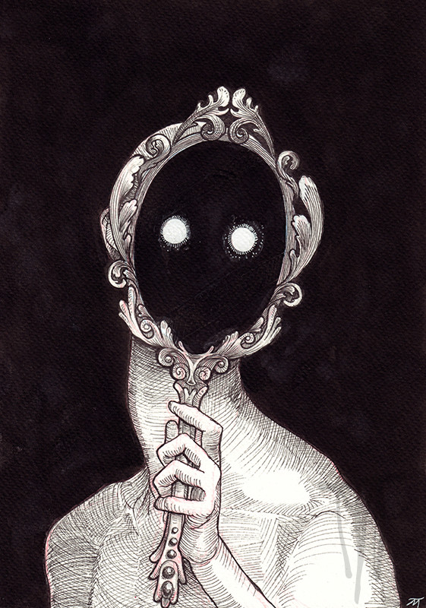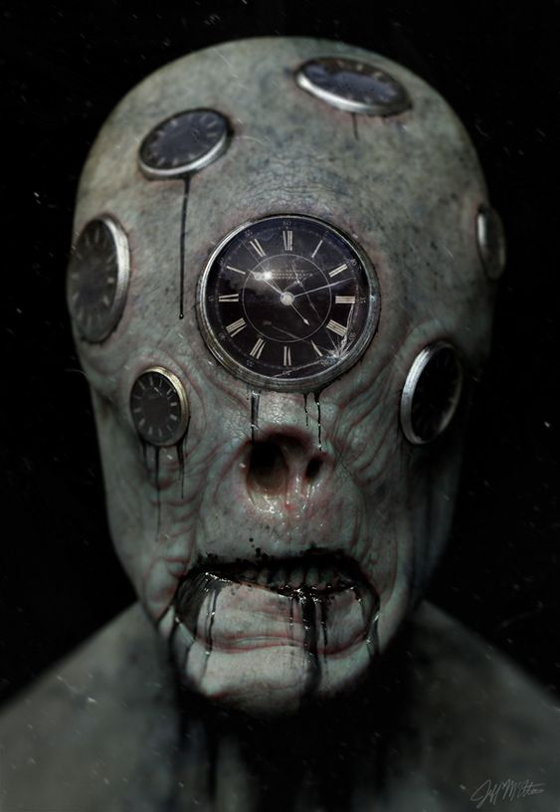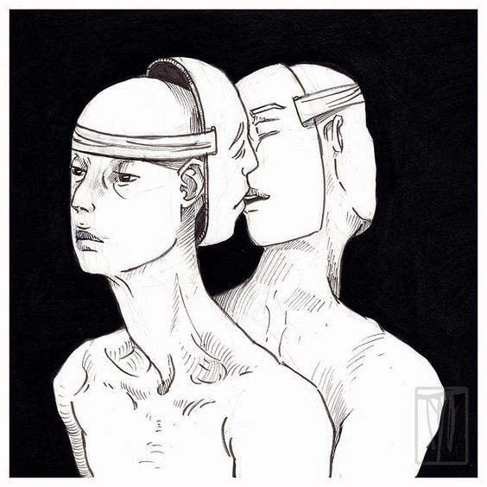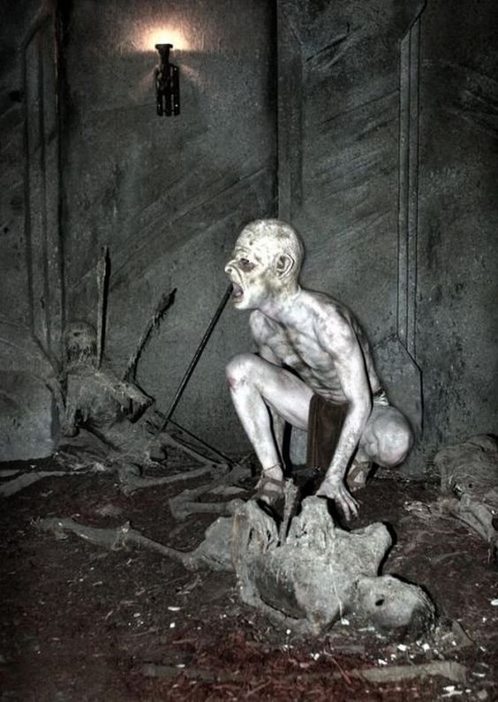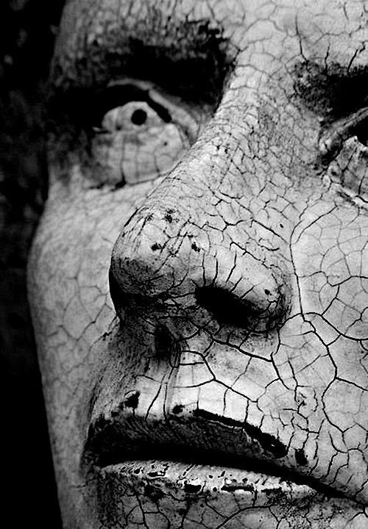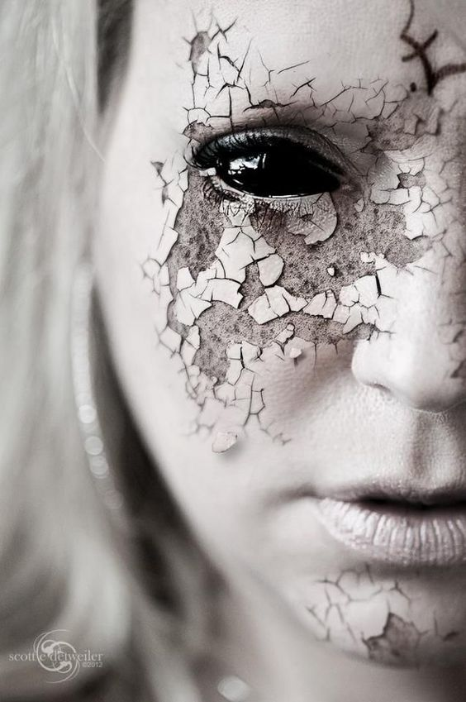

More concepts reference details:  
<https://www.myriamtillson.com/>

<https://www.instagram.com/myriamtillson/?hl=pt>

<http://myriamtillson.storenvy.com/>

Animation reference:

<https://www.youtube.com/watch?v=hm3BC8bM7q4> (Souls walking and behaviours)

<https://youtu.be/RoYB8egPTg8> (Souls moves and behaviours)